Remember  from the Water from the Wind

Do you know the difference between Watch and Warning?
Here is the Difference
Watch 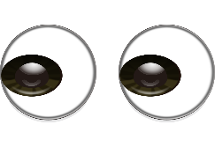
This Photo by Unknown Author is licensed under CC BY-NC-ND
Possibility of Life-threatening weather or inundation within 48 hours.

Warning 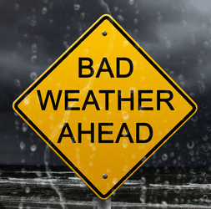
Danger of life-threatening weather or inundation withing 36 hours

