READY KIT
Choose your Container

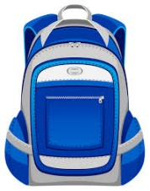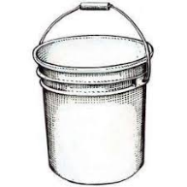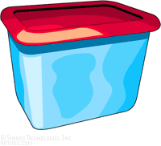

Gather your essential items and keep your kit where you can easily grab it in an emergency.

- Medications  - First Aid Kit  - Toiletries (Soap,  Toothbrush, ETC.)  - Flashlight  - Poncho  - Sunscreen  - Bug Spray  - Non-Perishable Food & Water  - Can Opener  - Multipurpose Tool  - Wet Wipes  - Hand Sanitizer  - Dust or Medical Mask  - Change of Clothes | - Cash  - Photos of Family Members and Pets for Re-unifications  - Important Family Documents in a Waterproof Bag  - Special Family Needs (Diapers, ETC.)  - Local Map  - Trash Bag  - Radio  - Extra Batteries  - Blanket  - Games/Entertainment Items  - Tarp  - Duct Tape
The first step is to choose a container that works for you. It can be a five-gallon bucket with a lid, a backpack or a plastic tote, the key is to make sure it works for your lifestyle and can be taken with you if you have to evacuate. Your kit should have enough supplies to sustain you for a minimum of five to seven days.

